  - Interview with Agrippina
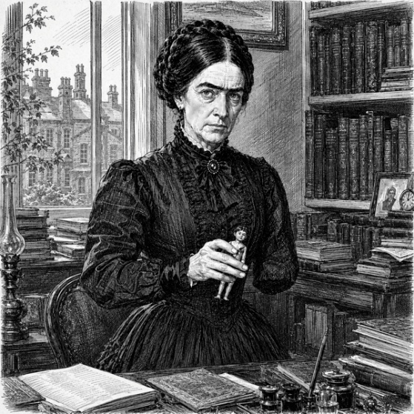
Agrippina Owtright was a small woman with only one arm and dark, heavy eyebrows that met in the middle above her nose, where more usually a gap occurs; she was dressed all in black like mourning. They were shown into the small library in her neat town house, where books lay scattered on desks and tables. She sat down behind a desk and waited while they settled themselves opposite her.
“You are Mr Scrooge?” she said, “I was told you were a smartly-dressed man, but you look dreadful. I suppose my brother somehow gave you that black eye.”
“He commissioned the giving of it,” agreed Scrooge, “and in retaliation I engaged a young ruffian to knock his hat off.”
“Did you!” she said, “Well, that is a little encouraging. I wish I could have seen it. And you Mr Marley; you are as I expected. Gentlemen, you are appallingly late.”
“It is scarcely noon by my watch,” said Marley, “if I misread your note, I am very sorry, but I understood that mid-day was the appointed hour?” She raised one side of her eyebrow in response.
“Oh, you are punctual to the appointment, Mr Marley,” she said, “I grant you that much. But I have been awaiting you in this room for thirty years or more. It isn’t your personal fault, of course, it isn’t Scrooge and Marley in particular that I have been waiting for; and in the end it doesn’t signify. You are here. You are here in time. You are late, but thank God, you are not too late, and my heart rejoices to see you, though I could wish you looked more gathered in your wits, more dangerous in your powers, and more implacable in your purpose. Yes, my heart rejoices; you think me solemn and dreary, I have no doubt, but I assure you my bosom is filled with joy and my soul with light, and I can tell you, gentlemen, that there is no pleasure in life that can equal the satisfied desire for a long-deferred revenge.”
“Now, Miss Owtright, I understand from your letter…” began Marley.
“Silence, fool!” said Agrippina, “I have much to say. I will tell you now the story of my past, and explain the consequences it has had, as well as those I intend it shall have in the future. Rest assured, you will obtain what you desire if you only listen.”

When Agrippina was eight years old, she told them, she received a magnificent doll’s house as a present from one of her aunts. It was a perfect miniature of an elegant house, with furniture, little rugs upon the floors, and even some tiny but just legible books in its rather limited library; one volume contained the Lord’s Prayer, another the first verses of Genesis. In the dining room and the kitchen there were some rather clumsy glasses with a capacity of one drop, as well as a fine array of different foods reproduced in plaster which were passed back and forth, never really consumed nor consumable, but adding greatly to the glory and verisimilitude of the scene. A family of dolls, consisting of Father, Mother, Big Boy, Little Girl, and The Baby inhabited this beautiful dwelling, served by a butler, maid, and cook. Agrippina named the family the Runcibles, and enacted domestic dramas with them until one day her elder brother James became bored with his toy yacht and chopped it up with a hatchet from the woodshed. At that point, having nothing else among his trains, his lead soldiers, his jigsaw puzzles and his story books that could hold his attention, he determined that he must now have the doll’s house. Agrippina protested that it was a girl’s toy, that in fact it was hers in particular, and neither suitable nor available to James. He burst into the nursery nevertheless, seized it in his arms – he could just barely hold it – and declared his intention of dropping it out of the window to the lawn below, where he proposed to ‘sort it out’. Agrippina, in tears, seized the other side and tried to prevent this act of destruction, but she was not as strong as James, who forced her back to the open window and then, inadvertently or otherwise, out of it.
“I could have been killed,” she told them, “but I was not. My arm was broken badly and poorly treated by an idiot of a doctor. Gangrene set in, and the whole arm had to be cut off. I was only eight, but I dare say that any chance of my making an acceptable marriage was carried away in the surgeon’s bucket with that arm, while I lay in agony on his blood-soaked table. He was a good surgeon, the fastest in England, but I shall never forget the terrible pain of the saw cutting into my bones.”
“I decided that I would affect forgiveness and even cordiality towards my brother, but that I should wait my time until an opportunity to destroy him presented itself. I may say that his self-love and vanity reassured him more than my friendliness, and in due course he agreed to make me mistress of a share in his company, assuming it would always be his to command at will. I have been waiting since then for an enemy to arise, one to whom I could hand my share, and with it, fatal power over my brother. But you have been an unconscionable time a-coming, gentlemen. My brother has cowed and intimidated every potential adversary without difficulty until now; poltroons, every one! Lovers of the quiet life, fools with no pride who embraced submission and defeat as their destiny and their natural due. Scrooge and Marley, you are not the implacable, competent predators that I have dreamed of, but still, be proud. In that dunghill they call the City, you are the first pair of worms in thirty years to grow backbones.” They were suitably impressed, and not a little disturbed.
“You will sell us your share,” said Marley softly, “so that we can wreak for you, upon your brother, revenge for the loss of your arm, and your prospects of happiness in life?”
“The arm is not the crux of it,” replied Agrippina, “One may do well enough without an arm if one is wealthy, as I am; and your easy equation of a husband with prospects of happiness bespeaks a masculine vanity of the type I know all too well. I have never regretted my spinsterhood. No; the revenge I seek is above all for my doll’s house, which he reduced to matchwood with his hatchet while I lay unconscious on the lawn, no-one heeding my accident for more than an hour, when finally Nurse Gekins came looking, not for me, but for him. Can you understand that in destroying the Runcibles he took from me a whole world, infinitely precious and forever most keenly regretted? I have spent the greater part of my life reading in this library, a traveller of the imagination in many lands, but none so wholly my own as that doll’s house realm.” She paused to gather herself, and looked searchingly into their faces.
“Mr Marley, I think, very slightly understands me;” she said, “I divine that he reads novels and has shed private tears by candlelight over poetry. But I see from his face that to Mr Scrooge my feelings about this are quite opaque. It is many years, I think, since he squeezed his imagination into a sturdy box and triple-locked the lid. Stories are childish things he put away when he became a man; nothing but the real and the enumerated are of interest to him now. I cannot imagine what it is like to live one’s life, as I suppose he must do, in the real world alone; the cramping of the imaginative faculty must be dreadfully painful, like the binding of a Chinese woman’s feet. But I wander from my purpose. Understand me, then, Scrooge and Marley; we are to kill my brother for that doll’s house and for no other reason.”
“Kill him? A lethal defenestration of your brother might be poetically just, Madam,” said Marley, “but surely excessive? I think we shall merely take and break his treasure as he took and broke yours, will we not?”
“It is the same thing, fool,” she replied, “to take his company from him is to deprive him of life just as surely as if you cut the beating heart from his chest. He will not survive, he cannot survive, and I do not intend and will not allow that he should survive.”
“I am entirely of your mind as to the probability of fatal consequences, Madam,” said Scrooge, “I cannot imagine your brother retreating into retirement in Cromer or some other place and living quietly, or living at all for that matter, once deprived of his company. My aim, indeed, is not to kill him; but he may perish if he chooses; it is no concern of mine. I am entirely of your mind in this too, that I will have my revenge, if by any means I may, whatever consequences may follow.”
“Now, Mr Ebenezer Scrooge, you sound a little more like the fellow I hoped you might be,” said Agrippina, allowing something that could have been the long-dead ghost of a smile on to her thin lips, “Big Boy is pleased with you and looks forward to avenging his family. You may see him.” She took from her desk drawer a little wooden boy doll with one cut gouged across its chest. “He alone survived,” she said, “all the others were beheaded and thoroughly dismembered.” They arranged to meet again the following day with Agrippina’s lawyer in order to complete the transaction. As they left the house, Marley leaned towards Scrooge and muttered.
“That woman’s brain is a bubbling pot of barm, my boy! Simply barm, and no wholesome beer beneath, either.”

